Air Quality Monitor

PROJECT REPORT

Abdul Hadi 216606 BESE-8B

Mashhood Ijaz 210946 BESE-8B

Muhammad Ahmad Naeem 210399 BESE-8B

Muneeb Aijaz 214268 BESE-8B

# Introduction:

AQM is a software that rates the quality of air at a location by detecting different gases in the environment and using real time data to calculate the air quality. It is useful for environmental sciences where it can be used to take actions upon the degrading quality of environment at the location.

## 1.1 Goals:

Our goal is to create a web-based system that will be used by Environmental Engineers to study the air quality variations at different places for taking precautionary measures in the future.

## 1.2 Restrictions and Constraints:

Currently the system is for indoor use only but it can be upgraded so that it can be used outdoors too.

# Overall Description:

## 2.1 Product Perspective:

As its main purpose is to provide information regarding the environment, it is user-friendly to the most possible extent so that it provides information with the least delay-time. As a web-based interface, the data is displayed on runtime or clusters which will make the user aware of the current conditions.

## 2.2 Product Functions:

The product measures different gases and show them with respect to time, with respect to the number of people present in the room or with respect to each other. It can also display data for individual room

## 2.3 User Characteristics:

According to the needs and demands of the system, the user can add more classrooms, more sensors or even other administrative users.

## 2.4 General Constraints:

The system is currently defined only for data collection, not for data manipulation and predicting the outcome.

# Specific Requirements:

## External Interface Requirements:

### 3.1.1. User Interface:

Users are able to monitor the air quality of any particular place in real time if a sensor is available. They would be able to compare it to the historical data of the same location.

### 3.1.2 Hardware Interface:

An air monitoring module that consists of smoke and methane sensors for now are used along with a programmable Arduino chip that normalizes that data and send it to the server.

Computer would be used to access the real-time air quality or history data, as data is sent to the server (currently hosted on the same machine as the client).

### 3.1.3 Software Interfaces:

MySQL 8.0 is used to store historical data. The frontend interface is devolved using Python Flask which allows the use of web browser hence the user can easily view the data.

### 3.1.4 Communication Interface:

Currently, the hardware is directly connected to the client computer using a COM5 port. But it can be easily upgraded to use WIFI in the future

## Design Constraints:

The product is currently created to accommodate data from two sensors but it can be easily adapted to add more sensors as nodes.

## Attributes:

* Data is easily visualized.
* Real-time data is accessible
* Data is specified on a map to compare the air quality of different areas
* The system is accessible through any compatible web server.

# Testing:

This program is heavily tested. Every user entry is verified and tested. In case of any side case, user is displayed a flashy message to show the error

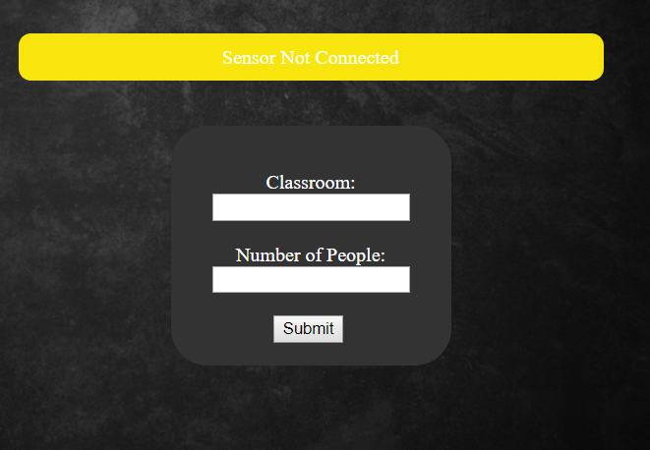

# Tools Used:

## Browser Side:

* HTML5 / CSS
* JavaScript – CanvasJS

## Hardware Side:

* Arduino Uno
* MH4 Sensor
* MH2 Sensor

## Server Side:

* ArdinoIDE
* Python - Serial
* Python - Flask
* MySQL Server

# Sequence Diagram:

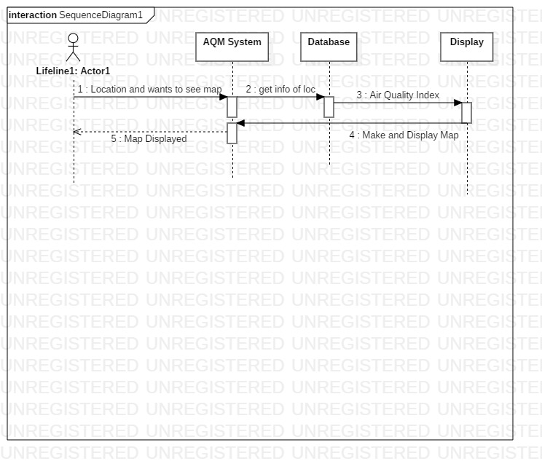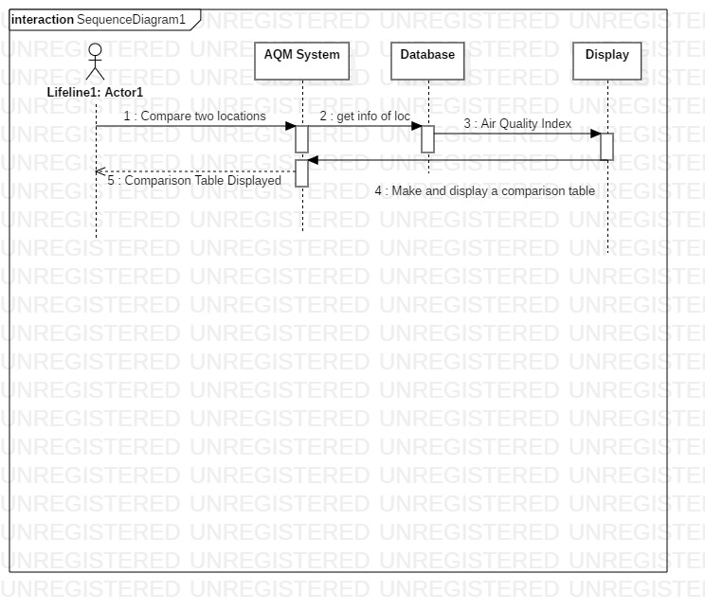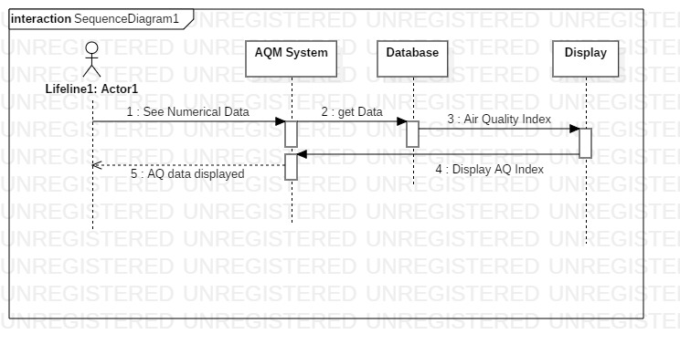

# Entity Relationship Diagram:

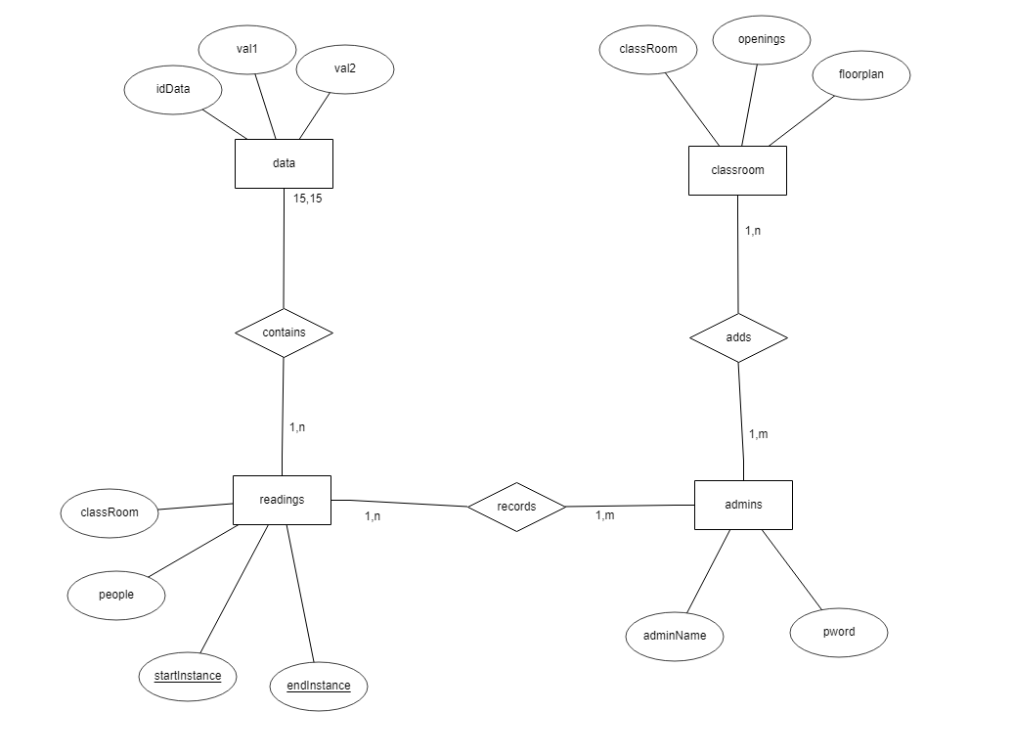

# Data Flow Diagrams:

## Level 0:

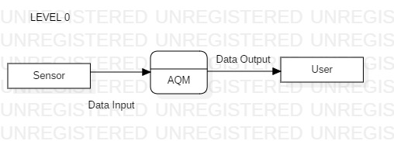

## Level 1:

